**Name:** Connor Colbert **Date:** 3/21/2022 **Max points:** 25

**Lab section:** Wednesday 11:30 AM

**Acquire**

Week: 36

Date: September 2nd Year: **2019** Data: [Season Preferences](https://data.world/makeovermonday/2019w36)

**Source Article/Visualization**: [Fall is favorite season for most Americans](https://today.yougov.com/topics/lifestyle/articles-reports/2013/06/10/fall-favorite-season-most-americans-33-heartland-l)

**Represent**

**Critique**

I like the colors chosen for the bars as they look visually appealing together. Although I like the colors, I feel like there is a lack of contrast that could cause problems with people with poor eyesight, so I will attempt to increase the contrast between the different age ranges. I will also be changing the graph type as the data does not fit the bar chart format well.

This data is organized in a bar chart, illustrates divergent thinking, and is an overview.

Based on your knowledge of the Periodic Table of Visualization Methods (discussed in class this week), discuss which one of the 6 categories does the visualization you provided in the Represent stage falls in. Identify the method most closely related to the visualization in the Represent Stage and discuss the characteristics: overview, detail, detail AND overview, divergent thinking, convergent thinking. Refer to Week 10 Readings to assist with categorizing the visualization.

**Mine**

* What is the favorite season of Americans by age group?
* How does the age of an American affect their favorite season?

**Filter**

**Show** (display, list, make it visible) the filtered data.

|  |  |  |
| --- | --- | --- |
| **Age group** | **Season** | **Preference value** |
| **18–34-year-olds** | Spring | 20.0% |
| **35–54-year-olds** | Spring | 25% |
| **55 and over** | Spring | 37% |
| **18–34-year-olds** | Summer | 30.0% |
| **35–54-year-olds** | Summer | 27% |
| **55 and over** | Summer | 20.0% |
| **18–34-year-olds** | Fall | 26% |
| **35–54-year-olds** | Fall | 31% |
| **55 and over** | Fall | 30.0% |
| **18–34-year-olds** | Winter | 13% |
| **35–54-year-olds** | Winter | 6% |
| **55 and over** | Winter | 4% |

|  |  |  |  |  |
| --- | --- | --- | --- | --- |
|  | Spring | Summer | Fall | Winter |
| **18–34-year-olds** | 20.0% | 30.0% | 26% | 13% |
| **35–54-year-olds** | 25% | 27% | 31% | 6% |
| **55 and over** | 37% | 20.0% | 30.0% | 4% |

**Stakeholders**

* The audience for this visualization is the general American population and of those who are curious which season is the most popular, especially amongst their own age group.
* I assumed the data is recent, with a large sample size, and without any entry errors.
* I used Tableau

**Sketch your Makeover**

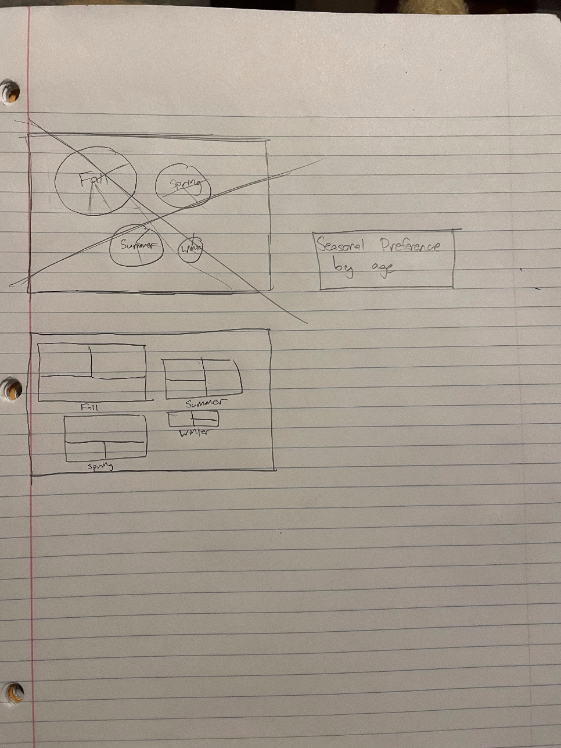

**Refine (Makeover – Landscape view)**

The preference of seasons by age of Americans. Based on the values in the squares, the colors, and the size, it is illustrated that Fall is the overall favorite season while Spring is favored by those 55 and older.

**Resources**

Data Visualization Checklist:

<http://stephanieevergreen.com/wp-content/uploads/2016/10/DataVizChecklist_May2016.pdf>

How to give constructive criticism:

<https://personalexcellence.co/blog/constructive-criticism/>

Sample Makeovers

<https://www.makeovermonday.co.uk/gallery/>

**Grading Rubric**

|  |  |  |  |
| --- | --- | --- | --- |
| **Excellent** | **Good** | **Fair** | **Needs Improvement** |
| Meets **ALL** or most of these: Makeover is esthetically pleasing (color, perception), best practices followed (insightful), Correct dataset downloaded; provided an interesting point of view of the data; critiqued previous makeover, critique is constructive (indicates one thing that is done well, and one thing that could be done differently, what will be done to improve the visualization), assumptions (more than one) are listed.  [15 pts] | Meets **MOST** of these: Makeover is esthetically pleasing (color, perception), best practices followed (insightful), Correct dataset downloaded; provided an interesting point of view of the data; critiqued previous makeover, critique is constructive (indicates one thing that is done well, and one thing that could be done differently, what will be done to improve the visualization), assumptions (more than one) are listed.  [10 – 14 pts] | Consistently meets **SOME** of these: Makeover is esthetically pleasing (color, perception), best practices followed (insightful), Correct dataset downloaded; provided an interesting point of view of the data; critiqued previous makeover, critique is constructive (indicates one thing that is done well, and one thing that could be done differently, what will be done to improve the visualization), assumptions (more than one) are listed.  [5 – 9 pts] | Little to no evidence of the understanding of the data visualization process.  Lackluster makeover or no makeover.  Little effort.  [0 – 4 pts] |
| Sketch included: hand drawn, data vis best practices evident.  [5 pts] | Sketch included: hand drawn, lacking data vis best practices.  [3 pts] | Sketch included, but was generated by computer  [2 pts] | No sketch included.  [0 pts] |
| More advanced chart types used  [5 pts] | More advanced chart types used, followed most best practices  [3 pts] | Basic chat types used in the makeover  [2 pts] | Little to no improvement in visual representation of the data [0 pts] |